

Name: Krishnaraj Prashant Thadesar. Class: F.Y B.Tech Division 9. Batch: I3.

Roll No.: 109054 Expt. No. 6 .

Performed on: 30/09/21 . Submitted on: 10/10/21 . Teacher’s Sign.: .

**Determination Of Moment Of Inertia Of Flywheel**

***Purpose of the experiment:***

To determine the moment of inertia of a Flywheel.

***Instruments****:*

Flywheel, string, stopwatch, weight, scale.

***Theory:***

A flywheel is always necessarily connected to engine shaft (crank shaft). The reason behind it is that the torque generated by the engine is *not* *constant* throughout the rotation of the crank shaft. That is two complete rotations of the crank shaft are required for the completion of four strokes which are known as *suction stroke, compression stroke, expansion stroke, and exhaust stroke*. In the four-stroke engine, the power is generated during the expansion stroke only. Thus, the process of power generation takes place only during that part of rotation at which power stroke (expansion stroke) is going on. Thus, if we do not use the flywheel, the *speed of the engine will be excessive during power stroke* and *will be very less for remaining three strokes*. Hence fluctuation of speed will be tremendous during one cycle.

Thus the function of the flywheel is to act as an energy reservoir which will store energy during those periods of crank rotation when the turning moment applied by the engine is greater than load moment to be overcome and will restore the energy during those periods when the turning moment is less than load moment to be overcome.

Absorption of energy is necessarily accompanied by *increase* of speed and restoration of energy is accompanied by *decrease* of speed. The mass moment of inertia of flywheel must be sufficient that these changes of speed do not exceed the permissible limits. *That is the change in speed should not be greater than 5 to $10\%$ of the mean speed.* Hence it becomes necessary for an engineer to design a flywheel of such mass, that its moment of inertia will regulate the speed so as not to exceed the limit of *5 to $10\%$ of the mean speed.*

*Moment of inertia of flywheel:*

Moment of inertia or second moment of small element of mass ' $dm$' about any axis is defined as the product of the mass ' $dm$' and the square of the perpendicular distance of an element from the axis of rotation. Moment of inertia of a rigid body about an axis passing through it, is defined as follows:

Moment of Inertia $=∫dm⋅r^{2}$

where the rigid body is split into number of small elements having infinitesimal small masses ' $dm$ and ' $r$' is its distance from the axis of rotation.



Thus, when the body is rotating it is its *'moment of inertia'* which opposes angular acceleration of the body and not its mass according to the Newtons first law of motion.

Moment of Inertia of flywheel =

I = $∫$ dm. $r^{2}……………$ (1)

*Kinetic Energy in Rotation:*

Kinetic energy of mass ' $m$' having velocity ' $v^{'}$ is given as

$$\frac{1}{2}mv^{2}.$$

In rotation only velocity has to be replaced by the quantity ' $rω^{'}$ where ' $ω^{'}$ is angular speed and ' $r^{'}$ is distance of rotating mass from axis of rotation. When the flywheel is considered as divide into a number of infinitesimally small mass elements and its corresponding distances from axis of rotation ' $r$' then kinetic energy of flywheel is given as follows:

Kinetic Energy of the Flywheel:

$$= \int_{_}{ } 2dm(rω)^{2}= \frac{1}{2}ω^{2}\int_{_}{ } dm⁡\left(r^{2}\right) =\frac{1}{2}Iω^{2}$$

*Experimental Determination of Moment of Inertia of Flywheel.*

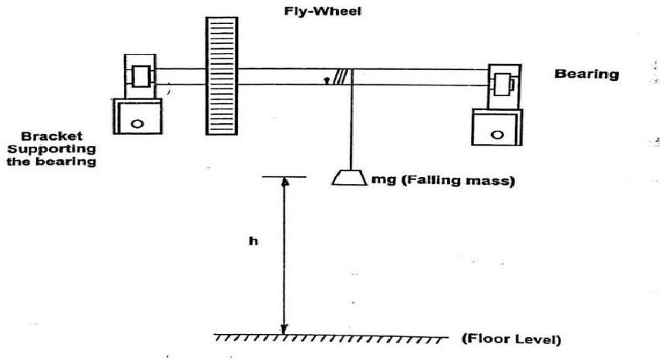

Figure Experimental setup to find M.I. of flywheel

To find out moment of inertia of fly wheel, a string is attached to the shaft, and it is wound on it for a certain number of turns and to the free end mass ' $m^{'}(kg)$ is attached at a height ' $h^{'}(m$) from the ground level as shown in the figure1. Then the system is released and the mass is allowed to fall to the ground and the time 't' (sec) required for the fall is noted.

*If $N_{1}=$ number of revolutions made by the flywheel till the mass strikes the ground.*

$N_{2}=$*number of revolutions made by the flywheel from the instant mass strikes the ground till the flywheel stops,*

$m=$*the mass attached to the free end of the string,*

$h=$*height of mass from ground level,*

$v=$*the velocity $(m/s)$ of the mass when it strikes the ground,*



$ω=$*angular velocity (rad/sec) of the flywheel at the instant the mass strikes the ground,*

$I=$*moment of inertia of flywheel $\left({kgm}^{2}\right)$,*

then,

*loss in potential energy due to fall of mass ' $m$' through the height ' $h^{'}=PE$ = Gain in kinetic energy of translation of the mass (KE1) + Gain in kinetic energy of rotation of the flywheel (KE2) + Work done against friction (WDF1)*

That is,

*PE = KE1+ KE2+ WDF1 ......... equation (2)*

where $PE=mgh$

$KE1=\frac{1}{2}{mv}^{2},v=$ velocity of mass when it is striking the ground.

$KE2=\frac{1}{2}Iω^{2}$

We have, by Kinematics, $h=ut+\frac{1}{2}{at}^{2}$ where,

$u =$*initial velocity*

$a=$*uniform acceleration at the instant at which mass touches the ground.*

$t =$*time required for mass to reach the ground*

$h =$*height*

*since the weight falls freely, $u=0$*

$$h=\frac{1}{2}{at}^{2}$$

$$a=\frac{2 h}{t^{2}}…(3)$$

Also we have the following kinematic equation for motion under uniform acceleration,

$v^{2}=u^{2}+2ah$ $=2ah$

$$u=0$$

$=2\left(\frac{2h}{t^{2}}\right)h$*(From equation 3)*

$$\left(\frac{4h^{2}}{r^{2}t^{2}}\right)…(4)$$

Also $ω^{2}=v^{2}/r^{2}$ where ' $r^{'}$ is the radius of the shaft.



$$ω^{2}=\frac{\left(\frac{4h^{2}}{t^{2}}\right)}{r^{2}}=\left(\frac{4h^{2}}{r^{2}t^{2}}\right)…(5)$$

$$\begin{matrix} & \text{ KE1 }=\frac{1}{2}{mv}^{2}=\frac{1}{2} m\left(\frac{4{ h}^{2}}{t^{2}}\right)={\left(\frac{2{mh}^{2}}{t^{2}}\right)}_{ }…From Equation (4) \\ & \end{matrix}$$

$$KE2=\frac{1}{2}Iω^{2}=\frac{1}{2}I\left(\frac{4{ h}^{2}}{r^{2}t^{2}}\right)=\left(\frac{2{Ih}^{2}}{r^{2}t^{2}}\right)…\text{ from equation }\text{(5)}$$

Kinetic Energy of rotation of the flywheel after mass is detached is KE2 and is consumed in overcoming the frictional couple which is assumed constant. It causes the retardation and brings the flywheel to come to rest. So, we have following equation:

$KE2=$ WDF2 $=$ Work done against friction

$=$ frictional couple ' $C^{'}×$ Number of revolutions $\left(N_{2}\right)$ made by flywheel after the mass is detached $×2π$

Hence,

$$WDF2=C.2πN_{2}$$

Putting this value in equation (4),

$$K.E.2=C.2πN_{2}$$

$$\frac{2{Ih}^{2}}{r^{2}t^{2}}=C\left(2πN_{2}\right) ………\text{ from equation (5) }$$

$$C=\frac{2{Ih}^{2}}{r^{2}t^{2}\left(2πN_{2}\right)}…(6)$$

Work done against friction W.D.F1.

$$\begin{matrix} & \text{ WDF1 }=C⋅\left(2πN_{1}\right) =\frac{2{Ih}^{2}}{r^{2}t^{2}\left(2πN_{2}\right)}×\left(2πN_{1}\right) \\ & \end{matrix}$$

$$=\frac{2Ih^{2}}{r^{2}t^{2}}×\frac{N_{1}}{N_{2}}…(7)$$

Putting the corresponding values in equation 2 we get

$$mgh=\frac{2mh^{2}}{t^{2}}+\frac{2{lh}^{2}}{r^{2}t^{2}}+\frac{2Ih^{2}}{t^{2}r^{2}}\frac{N_{1}}{N_{2}}$$

By rearranging the terms, we get.



$$I=\left(\frac{{mr}^{2}}{2 h}\right)\left({gt}^{2}-2 h\right){\left(\frac{N_{2}}{{ N}_{1}+N_{2}}\right)}_{}……kg/m^{2}$$

***Procedure:***

1. Measure the radius of axle ' $r^{'}(m)$ of the axle of the flywheel.
2. Attach one end of the string on the axle Then wind it on the axle after attaching the mass ‘m’ $(kg)$ at known height ‘h’ (m) from ground level.
3. Make a prominent chalk mark on the rim of the flywheel as a reference point for measuring its rotations.
4. Release the weight and start the stop watch at the same instant. Note the time ‘t’ (sec) for mass to reach .Count also the no. of rotations $N_{1}$ made by the flywheel before the mass reaches the ground .
5. Count the number of rotations $N_{2}$ made by the flywheel after the mass touches the ground till the flywheel comes to rest.
6. Repeat the above procedure three times with different combinations of ' $m$' and $^{'}h$' in such a way that the potential energy ' $mgh$' almost remains constant. 1) Gravitational Acceleration $\left.=g=9.81 m/\sec^{2} 2\right)$ Radius of the axle $=r=0.03 m$*.*

#### *Observations*

|  |  |  |  |  |  |  |  |
| --- | --- | --- | --- | --- | --- | --- | --- |
| Sr. No. | Mass m $(kg)$ | Height $[h]$ (meter) | Time $[t]$ (seconds) | $$N_{1}$$ | $${ N}_{2}$$ | $I$ $kg-m^{2}$ | $l(avg)$ $Kg-m^{2}$ |
| 1. | $$1.0$$ | $$0.738$$ | $$7.23$$ | 4 | 24 | $$0.267$$ | $$0.2618$$ |
| $$2.$$ | $$1.2$$ | $$0.945$$ | $$7.41$$ | 5 | 32 | $$0.265$$ | $$0.2618$$ |
| $$3.$$ | $$1.4$$ | $$1.155$$ | $$7.55$$ | 6 | $$40.5$$ | $$0.264$$ | $$0.2618$$ |
| $$4.$$ | $$1.6$$ | $$1.345$$ | $$7.31$$ | 7 | $$49.5$$ | $$0.244$$ | $$0.2618$$ |
| $$5.$$ | $$2.0$$ | $$1.565$$ | $$7.36$$ | 8 | 63 | $$0.269$$ | $$0.2618$$ |

#### *Formula:*



$$I=\left(\frac{m⋅r^{2}}{2 h}\right)\left(g.t^{2}-2.h\right){\left(\frac{N_{2}}{{ N}_{1}+N_{2}}\right)}_{\text{in }kg⋅m^{2}}$$

***Calculations: -***

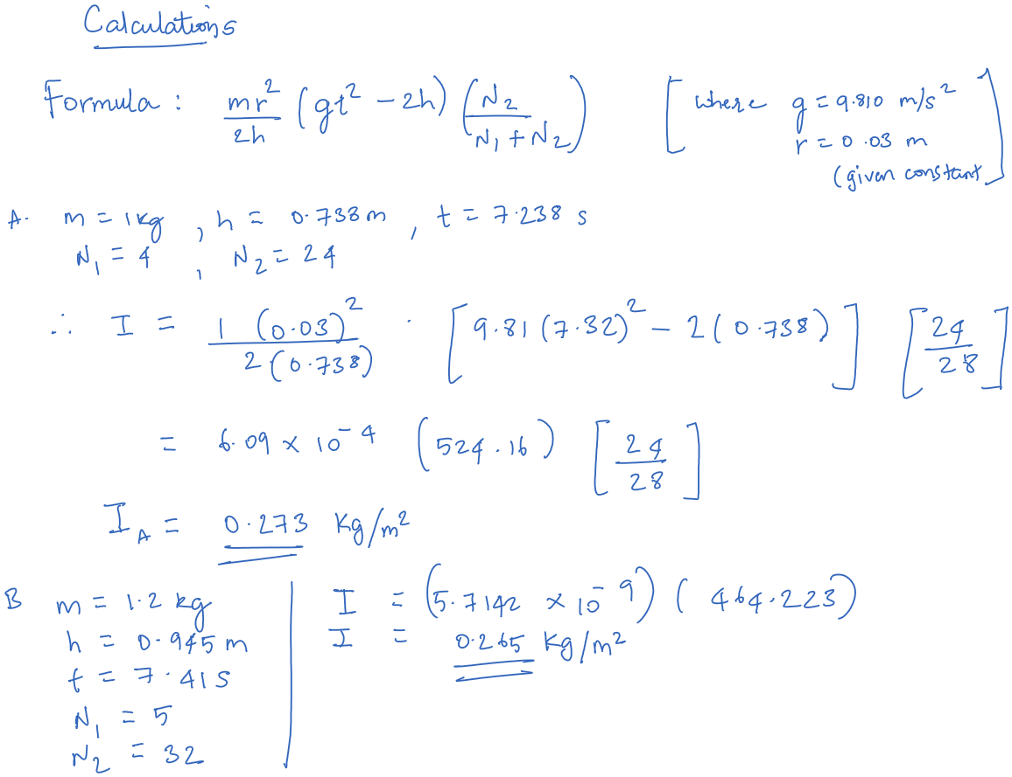

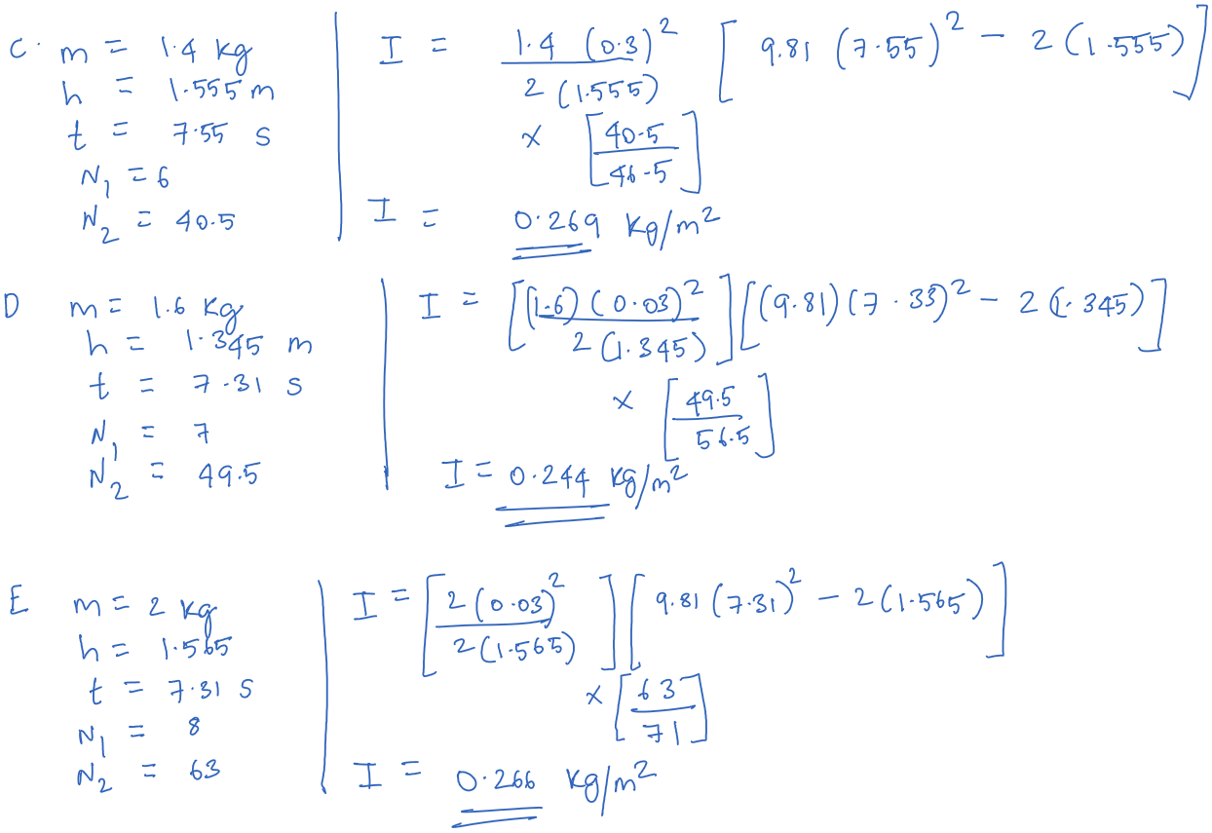

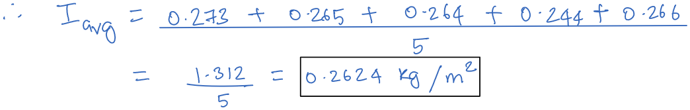



***Conclusion: -***

Through this experiment, the moment of inertia of a given fly wheel has successfully been determined by studying the principles and working of a generic fly wheels & then recording their movements and turns in stipulated conditions to eventually end up with a coherent set of readings that give out the average value of the Moment of Inertia as*: $0.2618 kg/m^{2}$*

***Questions: -***

1. What are the practical applications of fly wheel?
2. Used in multiple fields of practical applications:

Because flywheels act as mechanical batteries storing kinetic energy in the form of a rotating mass, the stored kinetic energy can easily be converted to electrical energy using electrical generators, thus making flywheels very useful in power storage devices for vehicles. They can be used in power hammers and riveting machines as well where it can act as a source of pulsating energy where the power levels needed are out of bounds for the energy source. Similarly, they may be used to make the source of energy continuous in case of discontinuity in supplied energy source. Similar properties make them handy in controlling directions and opposing unwanted motion which could be very helpful in gyroscopes.

1. What is the physical significance of moment of inertia?
2. Moment of inertia's physical manifestation is basically the resisting force within the body against any rotational change much like translational motion's mass. It thus acts a mass property of a rigid body that determines the torque needed to achieve a specific angular acceleration about any given axis of rotation.
3. What is radius of gyration?
4. Range of gyration or gyradius of a body about an axis of revolution is characterized as the radial distance to a point which would have a moment of inertia equivalent to the body's actual mass distribution, if the absolute mass of the body were concentrated there. Numerically the radius of gyration is the root mean square distance of the body's part from either its center of mass or a given axis, contingent upon the given application. Simply, we can describe it as the perpendicular distance from the point mass to the axis of rotation.
5. What is the parallel axis theorem of M.I.?
6. The parallel axis theorem of moment of inertia states that the moment of inertia of a body about an axis parallel to the body passing through its center is equal to the sum of moment of inertia of body about the axis passing through the center and product of mass of the body times the square of distance between the two axes given via the formulae:
$$I=I_{c}+{Mh}^{2}$$

7. What is the perpendicular axis theorem of M.I.?
8. Perpendicular axis theorem of M.I states that for any plane body the moment of inertia about any of its axes which are perpendicular to the plane is equal to the sum of the moment of inertia about any two perpendicular axes in the plane of the body which intersect the first axis in the plane. It is used when the body is symmetric in shape about two out of the three axes given by the formula:

$$Ia=Ib+Ic$$